**MUSIC Store Data Base Project**

**Query 1**

**Relation between Media Type and Milliseconds**

**select MediaType.Name,avg(Milliseconds)**

**from MediaType**

**join track**

**on track.MediaTypeId=MediaType.MediaTypeId**

**group by 1**

**order by 2 DESC**

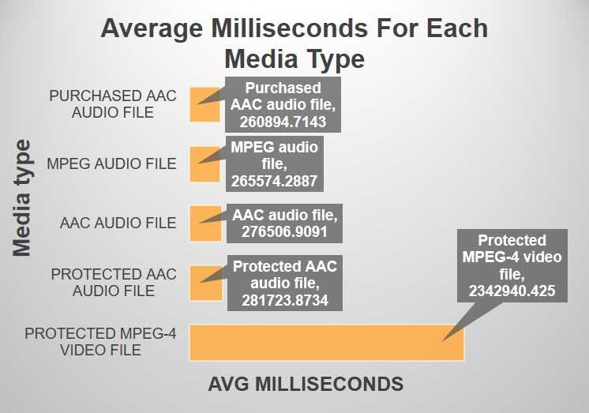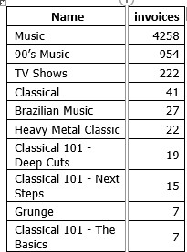

**Query2**

**Relation between genres and Total Price**

**select genre.Name,sum(InvoiceLine.unitprice*InvoiceLine.Quantity) AS TOTALPRICE**

**from Track**

**join Genre**

**on track.GenreId=Genre.GenreId**

**join InvoiceLine**

**on invoiceline.TrackId=Track.TrackId**

**group by 1**

**ORDER BY 2 DESC LIMIT 4**

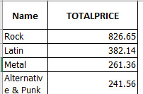

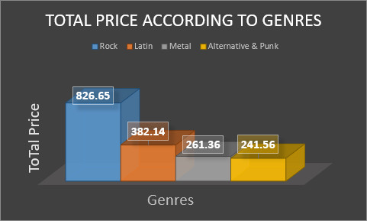

**Query 3**

**Relation between customer name and quantity**

**SELECT (Customer.FirstName ||" "|| customer.LastName) as customername,sum(invoiceline.quantity) AS Quantity**

**FROM Customer**

**JOIN Invoice**

**ON INVOICE.CustomerId=customer.CustomerId**

**join InvoiceLine**

**on invoice.InvoiceId=invoiceline.InvoiceId**

**group by customername**

**order by 2 DESC**

**limit 5**

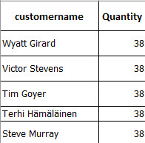

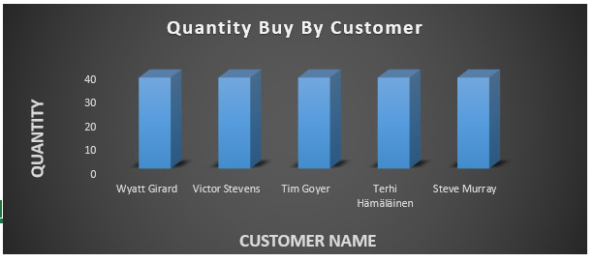

**Query 4**

**Reltion between Playlist and invoices**

**SELECT Playlist.Name,count(Invoice.total) as invoices**

**FROM Playlist**

**JOIN PlaylistTrack**

**ON Playlist.PlaylistId=PlaylistTrack.PlaylistId**

**JOIN Track**

**ON TRACK.TrackId=PlaylistTrack.TrackId**

**JOIN InvoiceLine**

**on InvoiceLine.TrackId=Track.TrackId**

**JOIN Invoice**

**ON Invoice.InvoiceId=InvoiceLine.InvoiceId**

**group by 1**

**order by 2 DESC**

